Un-named
[Email address]
Group Members
Dhanak Ambrose 2023-ag-9517
Fatima Afzal 2023-ag -9531
Employee Analysis
Apache Spark

Employee Analysis through Apache Spark
Practical Guide with Example

1. Load Dataset
Loading a dataset is the first step in any PySpark workflow. The spark.read.csv() function reads a CSV file into a Spark DataFrame, with header=True to use the first row as column names and inferSchema=True to automatically detect data types. The df.show() method displays the first 20 rows, and df.printSchema() prints the column names along with their inferred data types (string, integer, double, etc.).
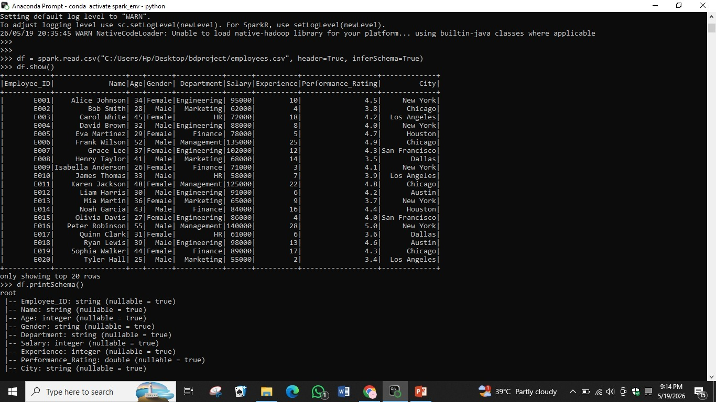
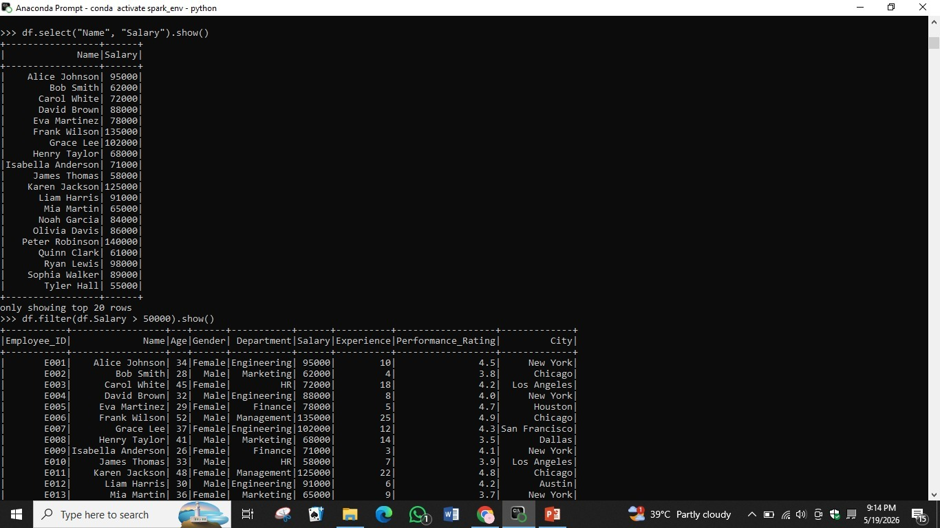

2. Display Data
Once a DataFrame is loaded, you can display specific columns using df.select(). For example, df.select('Name', 'Salary').show() retrieves only those two columns for all rows. You can also apply filters using df.filter() to display only records that meet a condition — for instance, df.filter(df.Salary > 50000).show() returns all employees whose salary exceeds 50,000.

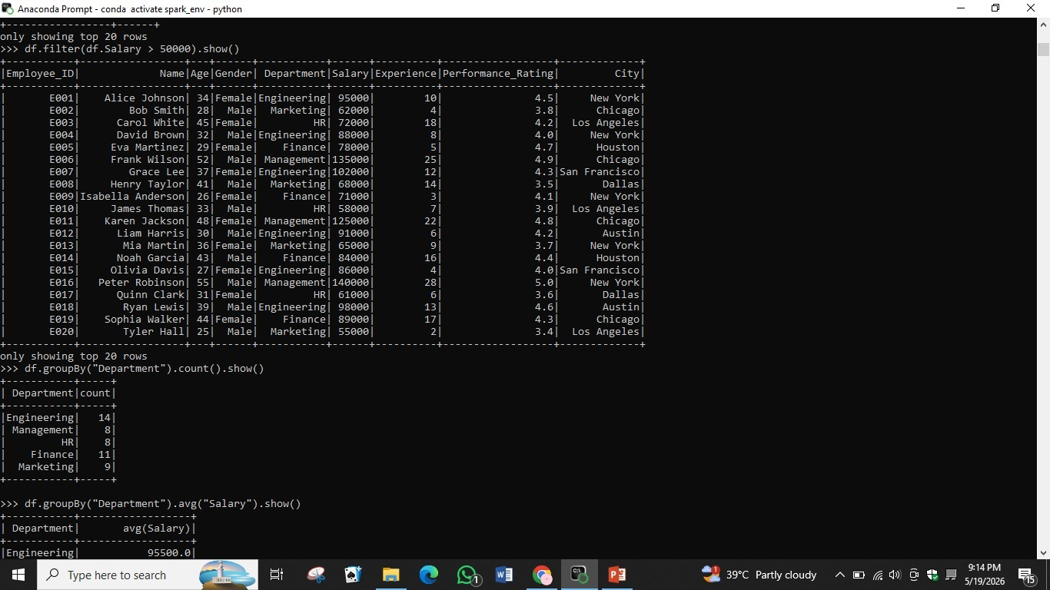

3. Filter Data (Salary > 50000)
Filtering allows you to extract a subset of rows that satisfy a given condition. The df.filter() method (or equivalently df.where()) accepts a column condition and returns a new DataFrame with only matching rows. In this example, all employees with a salary greater than 50,000 are displayed. Filtering is essential for data exploration and reducing dataset size before further processing
.

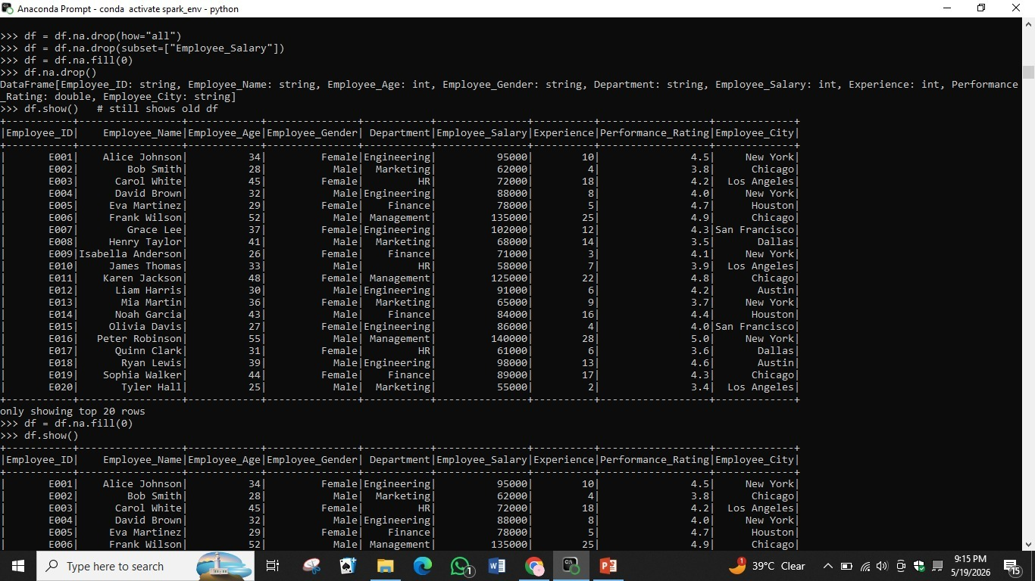

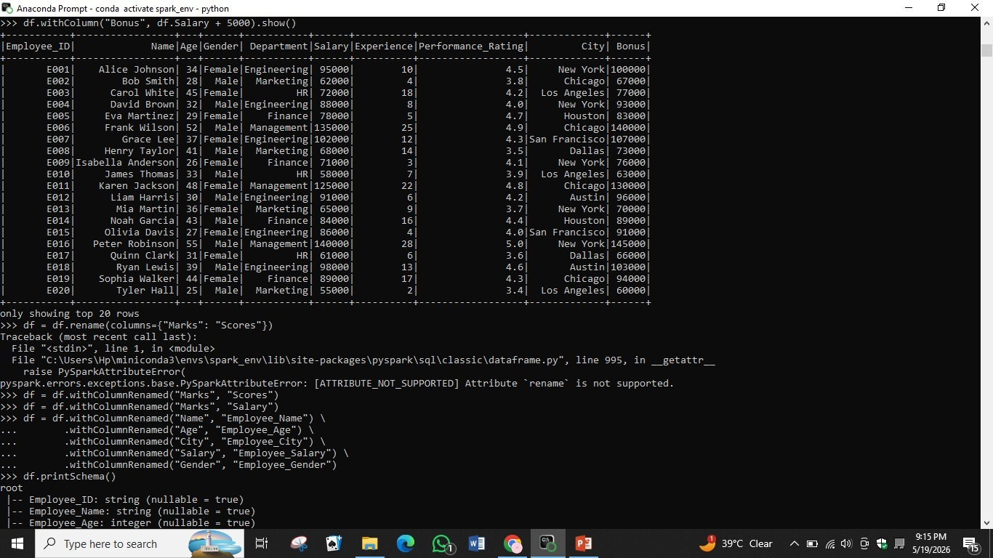

4. Group By Department
The groupBy() method groups rows by one or more columns and applies an aggregate function. Here, df.groupBy('Department').count().show() counts the number of employees in each department. The result shows that Engineering has 14 employees, Finance has 11, Marketing has 9, while HR and Management each have 8. This is useful for summarizing categorical data.

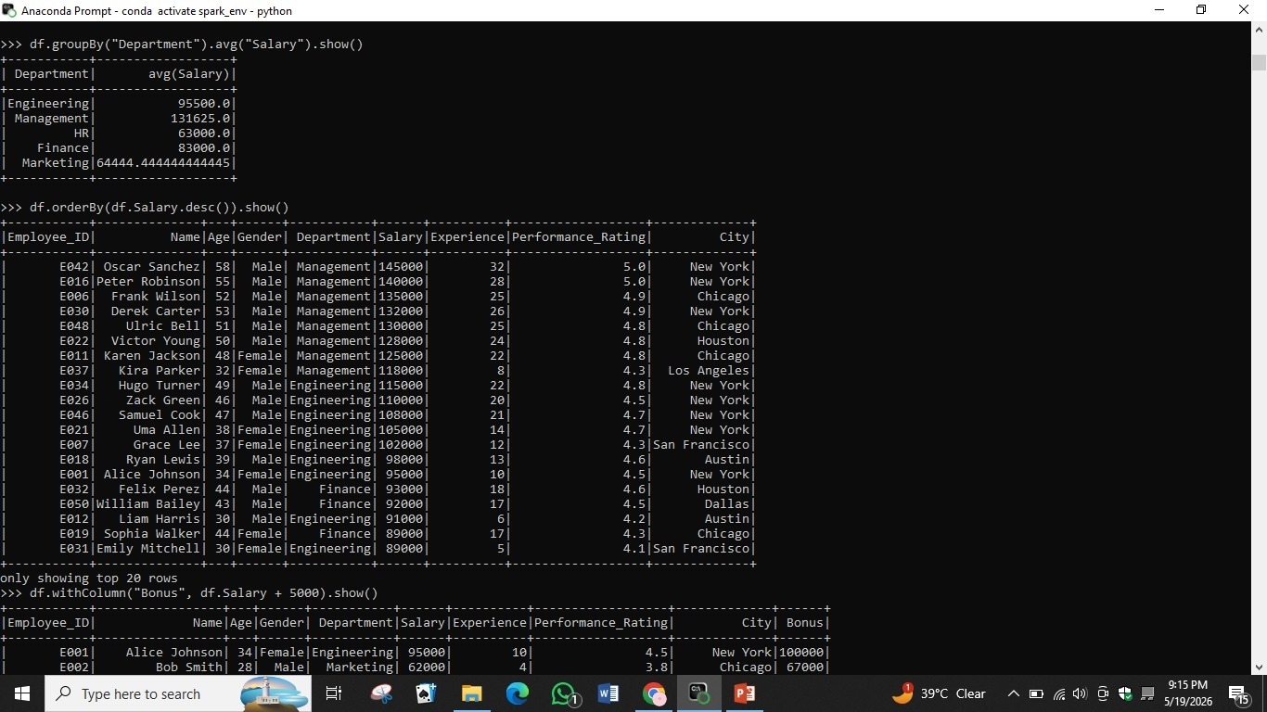

5. Find Average Marks / Salary
PySpark's pyspark.sql.functions module provides powerful aggregate functions. Using F.avg(), F.max(), F.min(), and F.count() inside a df.select() call allows you to compute multiple statistics in a single query. The result shows 50 total employees, a maximum salary of 145,000, a minimum of 55,000, and an average salary of 87,740. These statistics give a high-level overview of the dataset's numeric columns.

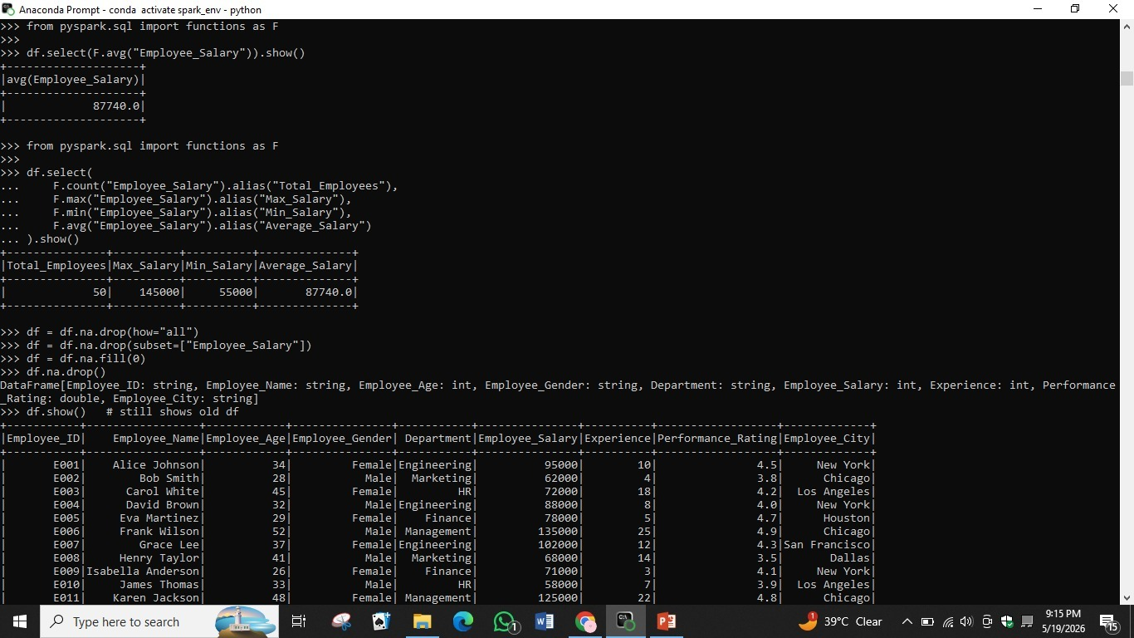

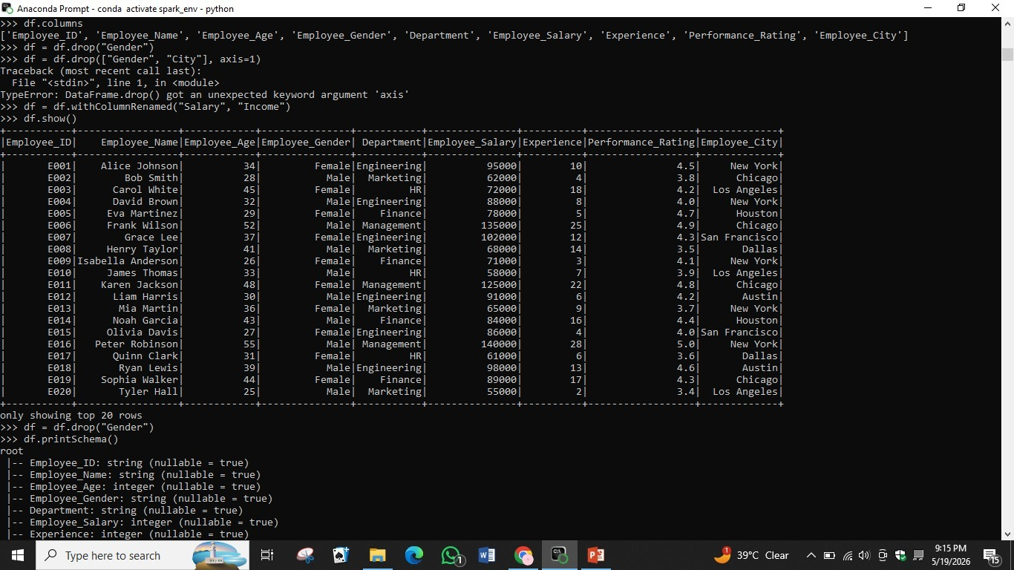

6. Sort Data
Sorting a DataFrame is done using df.orderBy(). By calling df.orderBy(df.Salary.desc()).show(), employees are listed from the highest to the lowest salary. The top earner is Oscar Sanchez in Management with a salary of 145,000, followed by Peter Robinson at 140,000. Sorting helps identify top and bottom performers and is often used before applying ranking or reporting logic.



7. Add New Column
New columns can be added to a DataFrame using the df.withColumn() method. In this example, df.withColumn('Bonus', df.Salary + 5000) creates a new 'Bonus' column by adding 5,000 to each employee's salary. Columns can also be renamed using df.withColumnRenamed(). Note that df.rename() is not supported in PySpark — withColumnRenamed() must be used instead, and multiple renames can be chained together.



8. Remove Null Values
Handling missing data is critical in data preprocessing. PySpark provides df.na.drop() to remove rows containing null values, and df.na.fill(0) to replace nulls with a specified value (such as 0 for numeric fields). You can also use df.na.drop(how='all') to only remove rows where every column is null, or df.na.drop(subset=['Employee_Salary']) to drop rows where a specific column is null. Since DataFrames are immutable, the result must be reassigned to a new variable.
